**Project Design Phase-II**

**Technology Stack (Architecture & Stack)**

|  |  |
| --- | --- |
| Date | 01 November 2023 |
| Team ID | NM2023TMID04504 |
| Project Name | Creating an Email Campaign in Mailchimp |

**Technical Architecture:**

The Deliverable shall include the architectural diagram as below and the information as per the table1 & table 2

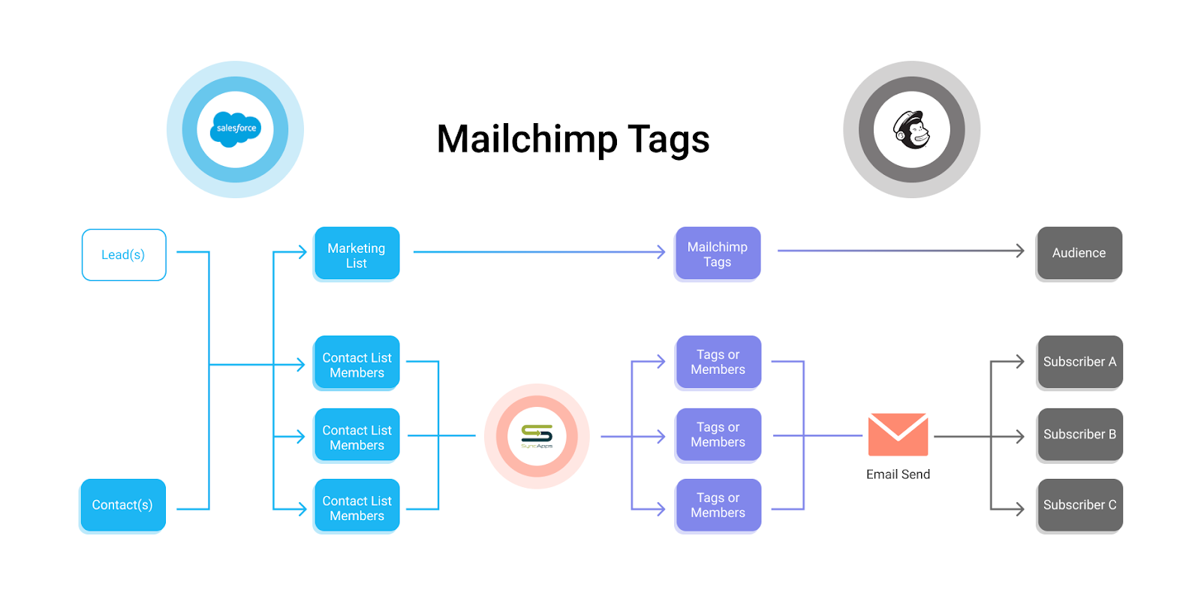

**Table-1: Components & Technologies:**

|  |  |  |  |
| --- | --- | --- | --- |
| **S. No** | **Component** | **Description** | **Technology** |
|  | Audience | The audience is the group of people you want to target with your email campaign. It could be your subscribers, customers, or a specific segment of your list. | Mailchimp provides tools for managing and segmenting your audience, including importing contacts, creating segments, and using tags and groups. |
|  | Email Content | The email content is the actual message you want to convey to your audience. This includes the email's design, text, images, and links. | Mailchimp offers a user-friendly email editor with drag-and-drop functionality, allowing you to create visually appealing emails without the need for coding |
|  | Email Template | Email templates are pre-designed layouts that help you maintain a consistent brand image in your emails. You can choose from Mailchimp's templates or create a custom one. | Mailchimp's template builder enables you to design or customize email templates without coding skills. |
|  | Subject Line | The subject line is the first thing your recipients see and can significantly impact your email's open rate. It should be enticing and relevant to your email's content. | Mailchimp provides a subject line preview and A/B testing features to help you optimize your subject line. |
|  | Scheduling | You can choose when your email campaign will be sent. Timing is important for maximizing open and click-through rates. | Mailchimp allows you to set the date and time for sending your emails and provides recommendations for optimal send times. |
|  | Tracking and Analytics | Tracking and analytics help you monitor the performance of your email campaign. You can see metrics like open rates, click-through rates, and conversion rates. | Mailchimp offers detailed analytics and reports, including visualizations and segmentation options to understand how your campaign is performing. |
|  | Testing and Optimization | To improve your email campaign's effectiveness, you can perform A/B tests on different elements like subject lines, content, or send times. | Mailchimp provides A/B testing features to help you optimize various aspects of your email campaigns. |
|  | Automation | Automation allows you to set up trigger-based emails, such as welcome emails, follow-ups, or abandoned cart reminders, to engage with your audience automatically. | Mailchimp's automation features enable you to create and manage automated email sequences. |
|  | Compliance and Legal Considerations | Ensuring that your email campaign complies with relevant laws and regulations, such as GDPR or CAN-SPAM, is essential to avoid legal issues. | Mailchimp provides compliance tools, such as opt-in forms and unsubscribe options, to help you adhere to email marketing regulations. |

**Table-2: Application Characteristics:**

| **S. No** | **Characteristics** | **Description** | **Technology** |
| --- | --- | --- | --- |
|  | User-Friendly Interface | Mailchimp offers an intuitive and user-friendly platform that caters to both beginners and experienced email marketers. | N/A |
|  | Email Template Customization | Users can access a wide range of pre-designed email templates and customize them to align with their brand's identity and message. | Drag-and-Drop Email Builder |
|  | Automation Capabilities | Mailchimp provides robust automation features for setting up triggered emails, drip campaigns, and personalized sequences, streamlining the email campaign process. | Automation Engine |
|  | Comprehensive Analytics | The platform offers detailed analytics and reporting tools, allowing users to track the performance of their email campaigns, from open and click-through rates to conversions. | Data Analytics and Visualization |
|  | Audience Segmentation | Mailchimp allows for the segmentation of email lists based on various criteria, facilitating targeted messaging to specific groups within the audience. | Segmentation Engine |